**LAB ASSIGNMENT-14.3**

**Task Description #1 – AI-generated HTML Page**

Task: Ask AI to generate a simple **HTML homepage** for a "Student Info Portal" with a header, navigation menu, and footer.

**Expected Output:**

* HTML code with <header>, <nav>, <footer>.
* Clean indentation, proper tags, and comments.

**PROMPT:**

Generate a simple **HTML homepage** for a "Student Info Portal" with a header, navigation menu, and footer with comments.

**CODE &OUTPUT:**

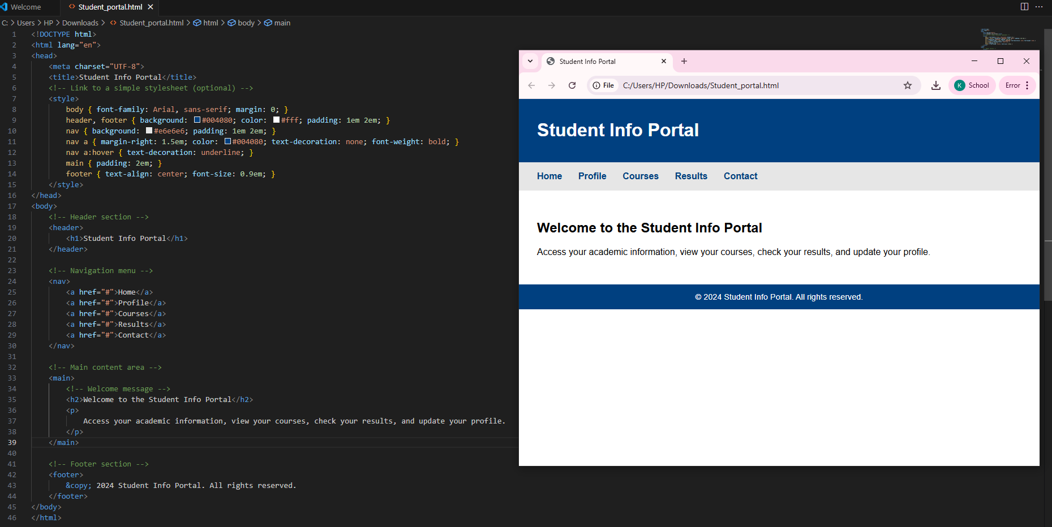

**OBSERVATION:**

This HTML code creates a clean and simple Student Info Portal page.

The structure is semantic, using header, nav, main, and footer elements.

The CSS is embedded in the head and provides a professional look with good color contrast.

The page is accessible and easy to read.

**Task Description #2 – CSS Styling**

**Task:**  
Use AI to add **CSS styling** to Task #1 homepage for:

* Responsive navigation bar.
* Centered content section.
* Footer with light gray background.

**Expected Output:**

* HTML + CSS combined.
* AI explains how CSS classes apply.

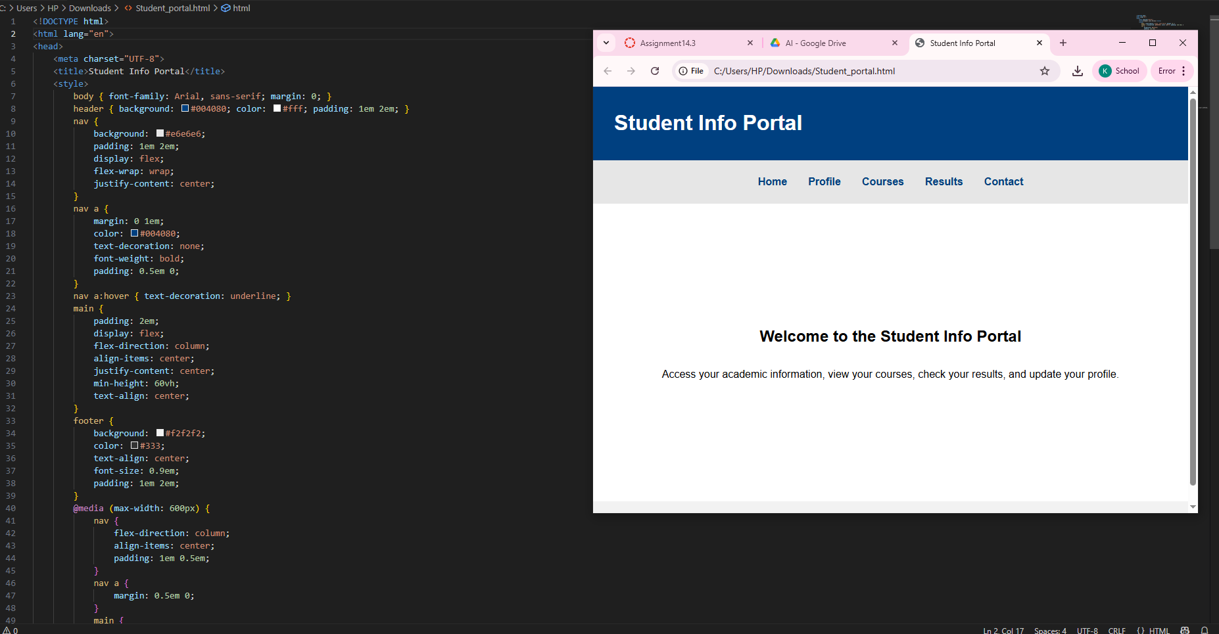

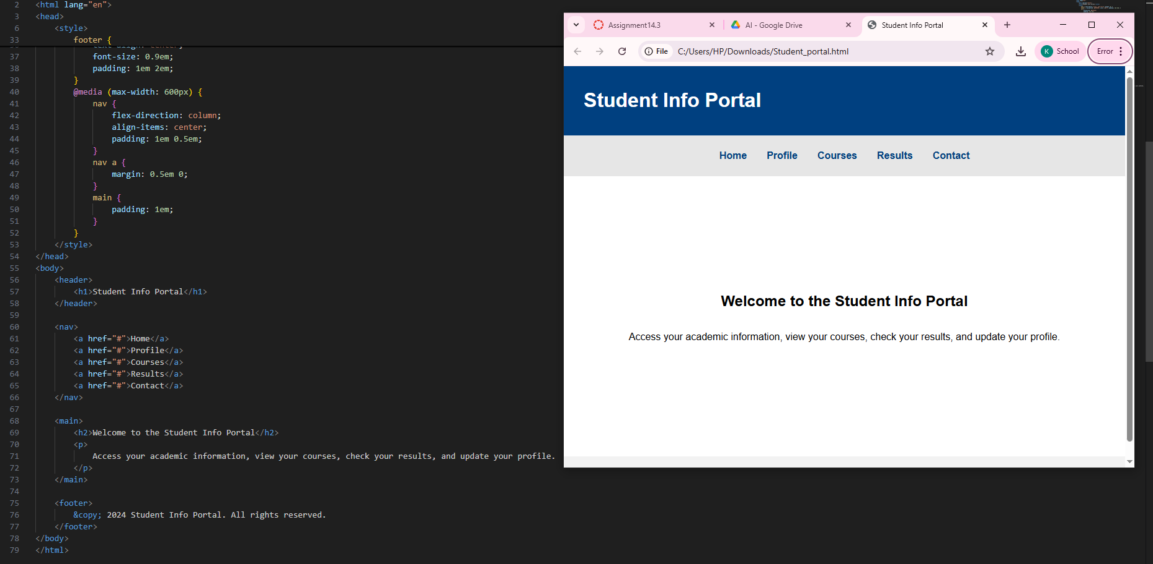

OBSERVATION:

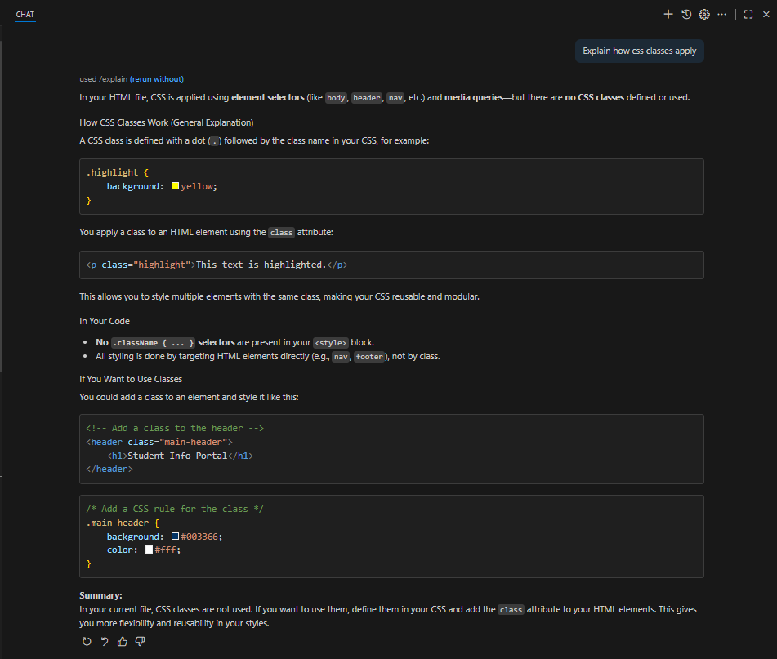

**Task Description #3 – JavaScript Interactivity**

**Task:** Prompt AI to generate a JS script that validates a simple login form (non-empty username/password).

**Expected Output:**

Working on submit JS validation.

Clear error messages if inputs are empty

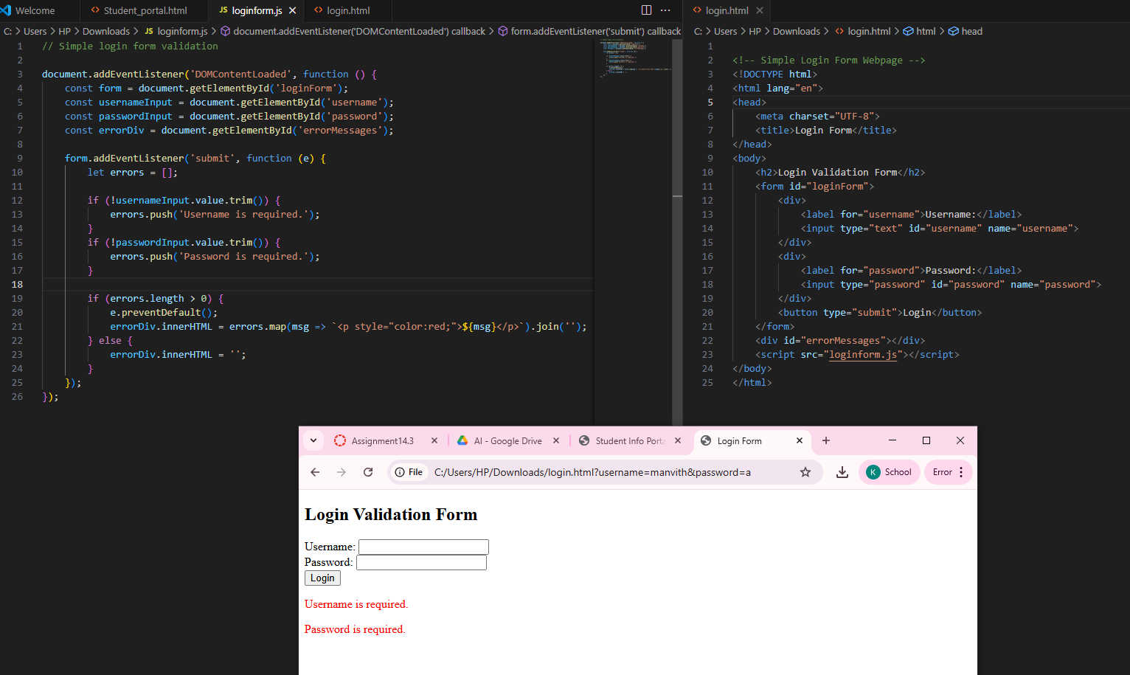

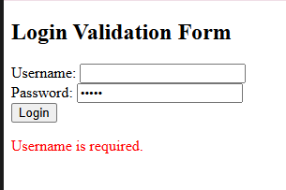

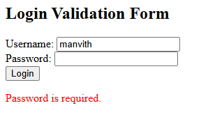

**Task Description #4 – Python Backend Integration**

Task: Ask AI to generate a Flask app that serves the HTML form (Task #3) and prints the username on successful login.

